**Spatially differentiated yield and economic risks of rice planting date strategies for Indo-Gangetic Plains: A computational risk modelling approach**

# Abstract

Advancing the planting date of rice has been heralded as the entry point for system optimization in rice-wheat rotational cropping systems in the Indo-Gangetic Plains (IGP). Much of the empirical evidence behind this recommendation focuses on the productivity and resilience benefits, but less on the monetary and risk implications of such planting date adjustments. Using gridded crop simulation model results and a computational risk model of evaluating risky portfolios, we assess the spatially differentiated economic potential of these alternative rice planting date strategies. We find that sowing a long duration rice variety at a fixed date recommendation is the most preferred option even for a risk averse farmer in the western parts of the IGP, while growing a long duration variety with monsoon onset is the preferred option for the eastern parts of the IGP.

# 1. Introduction

The Indo-Gangetic Plains (IGP) have been the food basket of South Asia through a dominant rice-wheat cropping rotation system. Rice is grown in the monsoon season from May to October (also called kharif) while wheat is grown as an irrigated crop in winter season from November to April (also called rabi). Climate change and variability especially due to late monsoon onset which affects rice sowing and terminal heat stress which has significant yield penalty on wheat have posed significant pressures to the rice-wheat cropping system in the region.

Recent compelling evidence (e.g., McDonald et al 2022, Urfels et al 2022, and Montes et al 2022) suggests that advancing the planting date of rice is one of the viable adaptation options. Using gridded crop simulations for the Indo-Gangetic plains, Urfels et al (2022) and Montes et al (2022) investigated the impact of different rice planting strategies (combining sowing dates, variety duration and irrigation) on system level productivity, resilience, and environmental benefits. In this paper, we extend the exante analyses to consider impacts of rice planting strategies on crop level and system level productivity and economic risks. The key contribution is to provide a robust decision making framework that adds to the average and interannual variability comparisons of the crop model results. The robust decision making framework allows one to make recommendations that are beneficial even for a risk averse farmer. This is important because though planting date strategy assessments assume a yield or profit maximizing farmer with risk neutral preferences, there is compelling evidence that most smallholder farmers are risk averse and that for this behavioural attribute even yield and profit increasing strategies would not be considered optimal. Recent studies (see, Hurley et al 2018, Suri 2011) have shown also shown that heterogeneity in returns to technology adoption and the associated risk preferences of farmers may result in lack of adoption of profitable agricultural innovations.

This paper contributes to two strands of literature. The first strand of literature is on stability analyses of agricultural technology benefits based on ex ante cropping system assessments (e.g., Urfels et al 2022, Montes et al 2022). Montes et al (2022) used inter-annual standard deviation to analyze the stability of the planting date scenarios. Urfels et al (2022) used deviation from the mean caloric yield for each of the years when a shock occurred as a measure of yield instability. These measures of yield stability while a step better than mean comparisons, they do not consider robustness of the optimal decision to risk aversion of the farmers. In addition, these measures do not consider higher order moments beyond mean and variability that may matter for distributional comparisons. In addition, we argue that stability analyses just as comparisons of means do not consider the trade-offs of achieving the highest returns with the lowest uncertainty.

These limitations are addressed in the second strand literature which focuses on the spatial risk assessment of economic benefits of agricultural innovations (e.g., Nalley and Barkley 2010, Hurley et al 2018). This literature attempts to optimize on the trade-offs of achieving the highest return and lowest uncertainty therefore allows one to choose strategies that are more robust. Using modern portfolio theory (Markowitz 1959) which suggests that a strategy to maximize average returns may be a suboptimal strategy, Nalley and Barkley (2010) used a mean-variance analysis to optimally select wheat varieties that achieve highest return and lowest risk. This strategy still suffers from the limitation of using a subset of moments (mean and variance) of the distribution. The stochastic dominance approach was developed to resolve these concerns in selecting robust strategies (Levy 2016). Using long term weather data, crop simulation model results (APSIM), spatially explicit observed maize prices, and fertilizer prices; Hurley et al (2018) simulates whether weather risk affects the adoption of fertilizer and improved maize seeds. They use heterogeneity in soils and climate in a calibrated crop growth model to simulate the distributions of yields across adoption of fertilizer and improved maize seed scenarios. They also assessed the heterogeneity of farmer risk preferences.

We specifically follow the approach proposed by Hurley et al (2018) to estimate willingness to pay bounds for a risk averse farmer to likely adopt an alternative rice planting date strategy. We depart from their approach in two substantial ways. First, instead of fertilizers and improved varieties, we consider multiple management changes including sowing dates, irrigation amounts, and varieties differing on duration to maturity. Second, we consider a rice-wheat multi-crop system unlike Hurley et al (2018) who focus on maize only. Our application therefore considers more complex decisions.

We find that sowing a long duration variety of rice with monsoon onset has the highest system economic benefits consistent with prior evidence that showed that this strategy gives higher system caloric yields.

The rest of the paper is organized as follows. We present next the methods focusing on the computational risk assessments. In section 3 we present results and discussion of the yield and economic benefits of alternative planting date strategies. We finally conclude in section 4.

# 2. Methods

## 2.1. APSIM spatially gridded crop model scenarios

The data used in this paper was based on pixelated APSIM crop growth simulation model results for climate variables for the period 1982-2015 reported in Urfels et al (2022) and Montes et al (2022). The crop simulation model is based on APSIM[1]. We use seven scenarios from crop simulation results reported in Urfels et al (2022). The scenarios correspond to variation in irrigation, varietal duration and the planting of rice at the onset of the monsoon. Table 1 shows the details for the scenarios.

Table 1: Scenarios

|  |  |  |
| --- | --- | --- |
| Scenario number | Rice planting strategy | Description |
| S0 | Farmer practice | Farmers’ practice baseline without nutrient and water limitations to understand current limits |
| S1 | Fixed long (baseline) | Planting long duration variety at a fixed recommended date (state recommendation) |
| S2 | Fixed medium | Planting medium duration variety at a fixed recommended date |
| S3 | Onset long | Planting long duration rice variety at the onset of monsoon |
| S4 | Onset long supp | Supplementary irrigation for planting long duration varieties at monsoon onset |
| S5 | Onset medium | Planting medium duration variety at monsoon onset |
| S6 | Onset medium supp | Supplementary irrigation for planting medium varieties at monsoon onset |

We supplement the APSIM model results with spatially gridded rice and wheat prices from the Landscape Diagnostic Survey data interpolated using a random forest model and back of the envelope spatially gridded irrigation costs.

## 2.2. Computational spatial ex-ante economic model under risk aversion

### 2.2.1. Yield risk

We compute spatially explicit willingness to pay bounds in rice and wheat yield equivalents for a risk averse farmer to definitely adopt or not adopt the interventions using second order stochastic dominance. Theoretically, second order stochastic dominance is related to the Arrow-Pratt measure risk aversion (Levy 2016). Meyer (1977) proved a theorem that cumulative distribution function $F(x)$ stochastically dominating $G(x)$ in the second order with respect to utility function $k(x)$ is equivalent to $F\left(x\right)$ being preferred or indifferent to $G(x)$ by all agents who are risk averse than an agent with utility function $k(x)$.

This implies that any risk averse farmer is likely to adopt if the yield advantage is such that the technology second order stochastically dominates another technology. We use a hypothetical experiment to demonstrate the approach (Figure 1). Based on mean comparisons, $G$ is clearly better than $F$ and $Q$. If we think in terms of distributional differences using first order stochastic dominance (Levy 2016), $G$ is clearly better than $Q$ because the cumulative distribution curve of $G$ is wholly to the right of $Q$. Consider next the case of $G$ and $F$ which have crossing cumulative distribution functions. For that comparison, second order stochastic dominance is needed to compare the area below and above the intersections. Visually, it can be deduced that $G$ second order stochastically dominates $F$. Consider the case of $F$ and $Q$, even though these have the same mean, one would want to choose which technology is better. It is difficult to visually assess the second order stochastic dominance ordering for these technologies. Using our approach, it is indeed unclear whether F stochastically dominates Q.

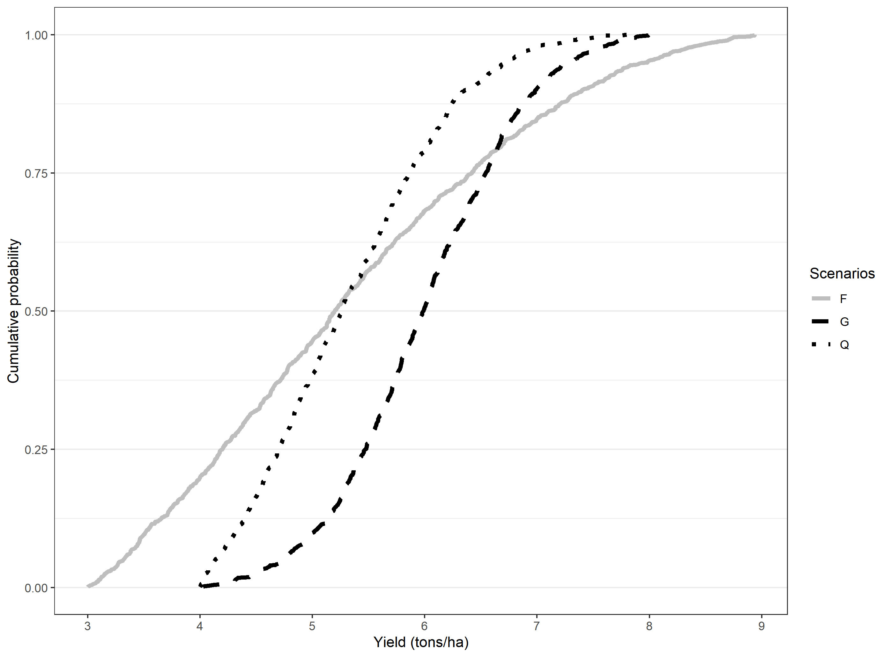

Figure 1: Hypothetical stochastic dominance assessment

***Note:*** We use a truncated normal distribution with four parameters: minimum (a), maximum (b), mean, and standard deviation (sd). The parameters used for each of the scenarios are as follows: G= rtruncnorm (n=1000,a=4,b=8, mean=6,sd=0.8), Q=rtruncnorm (n=1000,a=4,b=8, mean=5,sd=1), F=rtruncnorm (n=1000,a=3,b=9, mean=5,sd=2).

Beyond establishing second order stochastic dominance, it is important to understand how much yield advantage is needed for one technology to second order dominate another. For this, we use an approximation to compute the lower and upper bounds for one technology to second order stochastically dominate another.

The lower WTP bound that makes any risk-averse farmer prefer new technology (in this case scenarios other than the baseline) can be derived using second order stochastic dominance (see Hurley et al 2018 for detailed derivations). If both lower bound and upper bound are positive, then any risk averse farmer will prefer the new technology. Conversely, if both lower bound and upper bound are negative, then any risk averse farmer will stick to the old technology. If however, the lower bound is negative and the upper bound is positive, then it is requires an explicit understanding of risk preferences—information not easily available—to determine which distribution is preferred. We use Octave for the computational analyses.

Proceeding with the hypothetical distributions, we show in table 2 results from using our approach to compute upper and lower willingness to pay bounds. The WTP bounds are positive for the comparison between Q and G as well as F and G.

Table 2: Hypothetical distributions and willingness to pay bounds

|  |  |  |  |
| --- | --- | --- | --- |
| Panel (a): Truncated normal distribution parameters for the hypothetical distributions | | | |
| Truncated normal parameters | G | Q | F |
| N | 1000 | 1000 | 1000 |
| Min=a | 4 | 4 | 3 |
| Max=b | 8 | 8 | 9 |
| Mean | 6 | 5 | 5 |
| SD | 0.8 | 1 | 2 |
| Panel (b): Willingness to pay bounds from computational second order stochastic assessment | | | |
|  | Q(base)  vs G | Q vs F | F vs G |
| WTP lower bound (t/ha) | 0.036 | 0 | 0.499 |
| WTP upper bound (t/ha) | 0.763 | 0.218 | 1.384 |
| Interpretation | G F/SOSD Q | Not clear | G SOSD F |

The sign for the WTP bounds gives the evaluation of the benefits of the technology for a risk averse farmer. If both upper and lower bounds are positive, the farmer is willing to pay for that strategy. The upper bound is the amount of money that would pay just to stay with the new technology, while the lower bound is the amount that would pay just to be indifferent between the new strategy and the base strategy. For negative WTP for upper and lower bound, it shows that they would need to be paid to accept the proposed strategy. Lower bound is the amount of money that they would accept to abandon their existing strategy. Upper bound is the amount of money that they would accept just to be indifferent between the new strategy and their existing strategy.

### 2.2.3. System economic benefits under risk

For cropping system assessment, we focus on the revenues and partial profits (revenue-cost of irrigation) derived from both rice and wheat. Willingness to pay is therefore in monetary terms rather that quantity terms. We use the same approach as stated above to determine if it is beneficial for a risk averse farmer to adopt the planting date strategy. When the revenue WTP is compared to cost of production differences between the baseline and the proposed strategy, we get the profit potential for the farmers in each pixel.

# 3. Results

## 3.1. Yield benefits over baseline for risk averse farmer

### 3.1.1. Rice

Table 3 shows the descriptive statistics on the willingness to pay bounds (ton/ha) in rice yield equivalent for the planting date scenarios in comparison to the fixed date with long duration variety planting strategy. The WTP summary rows show the percentage of farmers who are more likely to benefit, be worse off or be indifferent between the planting date strategies. Only 31% of the farmers would find the onset long as beneficial followed by fixed medium (30%). For farmer practice, the average and median WTP bounds (both lower and upper) are negative implying that farmers will have to be paid to be indifferent or prefer it as compared to fixed date with long duration variety planting strategy.

Table 3: Rice WTP bounds with fixed long as baseline, IGP

|  |  |  |  |  |  |  |  |
| --- | --- | --- | --- | --- | --- | --- | --- |
| Bound | Statistics | S0-S1 | S2-S1 | S3-S1 | S4-S1 | S5-S1 | S6-S1 |
| Upper bound | Mean | -1.03 | 1.90 | 0.76 | 0.41 | 1.32 | 1.01 |
| Std.Dev | 1.36 | 1.75 | 2.50 | 2.38 | 1.79 | 1.76 |
| Min | -5.65 | -2.47 | -5.58 | -5.65 | -4.23 | -4.38 |
| 10th percentile | -2.17 | -1.60 | -2.26 | -2.35 | -1.65 | -1.53 |
| 25th percentile | -1.85 | 1.32 | -0.58 | -0.88 | 0.66 | -0.47 |
| Median | -1.33 | 2.48 | 0.04 | -0.30 | 1.77 | 1.53 |
| 75th percentile | -0.45 | 3.04 | 3.18 | 2.86 | 2.38 | 2.20 |
| 90th percentile | 0.15 | 3.52 | 4.11 | 3.68 | 3.06 | 2.93 |
| Max | 5.92 | 5.64 | 5.73 | 5.65 | 10.95 | 8.90 |
| Lower bound | Mean | -3.53 | -0.73 | -1.42 | -2.02 | -1.27 | -1.49 |
| Std.Dev | 1.68 | 1.73 | 2.60 | 2.47 | 1.78 | 1.68 |
| Min | -7.83 | -4.69 | -7.02 | -6.16 | -7.02 | -7.20 |
| 10th percentile | -5.53 | -2.47 | -5.13 | -5.19 | -2.75 | -3.20 |
| 25th percentile | -4.62 | -2.03 | -3.76 | -4.41 | -2.28 | -2.52 |
| Median | -3.71 | -1.15 | -0.71 | -1.87 | -1.51 | -1.82 |
| 75th percentile | -2.32 | 0.35 | 0.18 | -0.14 | -0.34 | -0.54 |
| 90th percentile | -1.89 | 1.92 | 1.90 | 1.18 | 1.16 | 0.73 |
| Max | 4.84 | 5.05 | 4.79 | 4.66 | 8.50 | 6.49 |
| WTP summary | Clearly better (share) | 0.02 | 0.30 | 0.31 | 0.21 | 0.21 | 0.18 |
| Not clear (share) | 0.11 | 0.52 | 0.21 | 0.19 | 0.59 | 0.53 |
| Clearly worse (share) | 0.87 | 0.18 | 0.49 | 0.60 | 0.21 | 0.29 |
| Number of cells | 17411.00 | 17412.00 | 17420.00 | 17421.00 | 17421.00 | 17421.00 |

Note: The number of cells are lower for S0-S1, S2-S1 and S3-S1 due to missing information in some of the pixels.

Figure 2 shows the spatial clustering of pixels for which the proposed planting strategy is clearly better, better or worse and clearly worse than the fixed calendar date state recommendation with long duration variety strategy. Among these, planting with monsoon onset with a long duration strategy seems to provide much advantage in the eastern part of IGP. The western part seems to benefit more from the fixed date recommendation with long duration variety.

Figure 2: Willingness to pay **(rice yield t/ha)** for the strategy against a fixed long duration variety reference strategy using second order stochastic dominance

### 3.1.2. Wheat

Table 4 shows descriptive statistics of the willingness to bounds in wheat yield equivalent (t/ha) for the scenarios in comparison to fixed date recommendation with long duration rice variety rice planting strategy (here after called fixed long strategy). Column (S0-S1) shows the comparison between farmer practice and fixed long strategy. It is apparent from the lower bound estimates, almost 90% of farmers have negative WTP lower bound for the farmer practice strategy when compared with the fixed long strategy. For about 25% of these, even the upper WTP is negative. Farmer practice is good strategy for risk averse farmers for only about 4% of the pixels. For wheat the best strategy seems to be fixed medium rice planting strategy in that most of pixels (86%) will benefit with higher wheat yields as compared to the fixed long rice planting strategy.

Table 4: Wheat WTP bounds (ton/ha) with fixed date-long variety scenario as baseline, IGP

|  |  |  |  |  |  |  |  |
| --- | --- | --- | --- | --- | --- | --- | --- |
| Bound | Statistics | S0-S1 | S2-S1 | S3-S1 | S4-S1 | S5-S1 | S6-S1 |
| Upper bound | Mean | -0.50 | 1.00 | 0.22 | -0.88 | 0.17 | -0.65 |
| Std.Dev | 0.83 | 0.46 | 0.64 | 1.19 | 0.70 | 1.14 |
| Min | -5.47 | -0.08 | -1.16 | -4.06 | -1.56 | -4.19 |
| 10th percentile | -1.89 | 0.28 | -0.58 | -2.55 | -0.76 | -2.19 |
| 25th percentile | -0.71 | 0.71 | -0.18 | -1.78 | -0.42 | -1.63 |
| Median | -0.29 | 1.09 | 0.08 | -0.79 | 0.20 | -0.50 |
| 75th percentile | 0.00 | 1.34 | 0.54 | -0.06 | 0.75 | 0.29 |
| 90th percentile | 0.28 | 1.53 | 1.28 | 0.77 | 1.11 | 0.75 |
| Max | 1.59 | 1.99 | 2.05 | 1.91 | 1.78 | 1.61 |
| Lower bound | Mean | -1.94 | 0.49 | -0.37 | -1.69 | -0.37 | -1.62 |
| Std.Dev | 1.45 | 0.37 | 0.83 | 1.45 | 0.79 | 1.47 |
| Min | -7.00 | -0.55 | -2.29 | -6.67 | -2.29 | -6.67 |
| 10th percentile | -3.88 | -0.02 | -1.49 | -3.69 | -1.50 | -3.65 |
| 25th percentile | -3.15 | 0.27 | -0.90 | -2.97 | -1.01 | -2.83 |
| Median | -2.14 | 0.49 | -0.37 | -1.64 | -0.21 | -1.70 |
| 75th percentile | -0.58 | 0.70 | 0.15 | -0.52 | 0.28 | -0.17 |
| 90th percentile | -0.04 | 1.07 | 0.79 | 0.29 | 0.47 | 0.24 |
| Max | 1.34 | 1.34 | 1.62 | 1.49 | 1.35 | 1.23 |
| WTP summary | Clearly better (share) | 0.04 | 0.86 | 0.28 | 0.15 | 0.40 | 0.20 |
| Not clear (share) | 0.20 | 0.12 | 0.35 | 0.09 | 0.19 | 0.14 |
| Clearly worse (share) | 0.75 | 0.01 | 0.37 | 0.76 | 0.41 | 0.66 |
| Number of cells | 17421.00 | 17421.00 | 17421.00 | 17421.00 | 17421.00 | 17421.00 |

Figure 3 shows the spatial distribution of willingness to pay classifications categorizing strategies on wheat yield whether they are worse, better or worse, and better than the fixed long rice planting strategy. Fixed planting of a medium duration rice variety seems to be the best strategy to ensure higher wheat yields across all locations most locations in IGP except the northwestern side where one would be indifferent (12%).

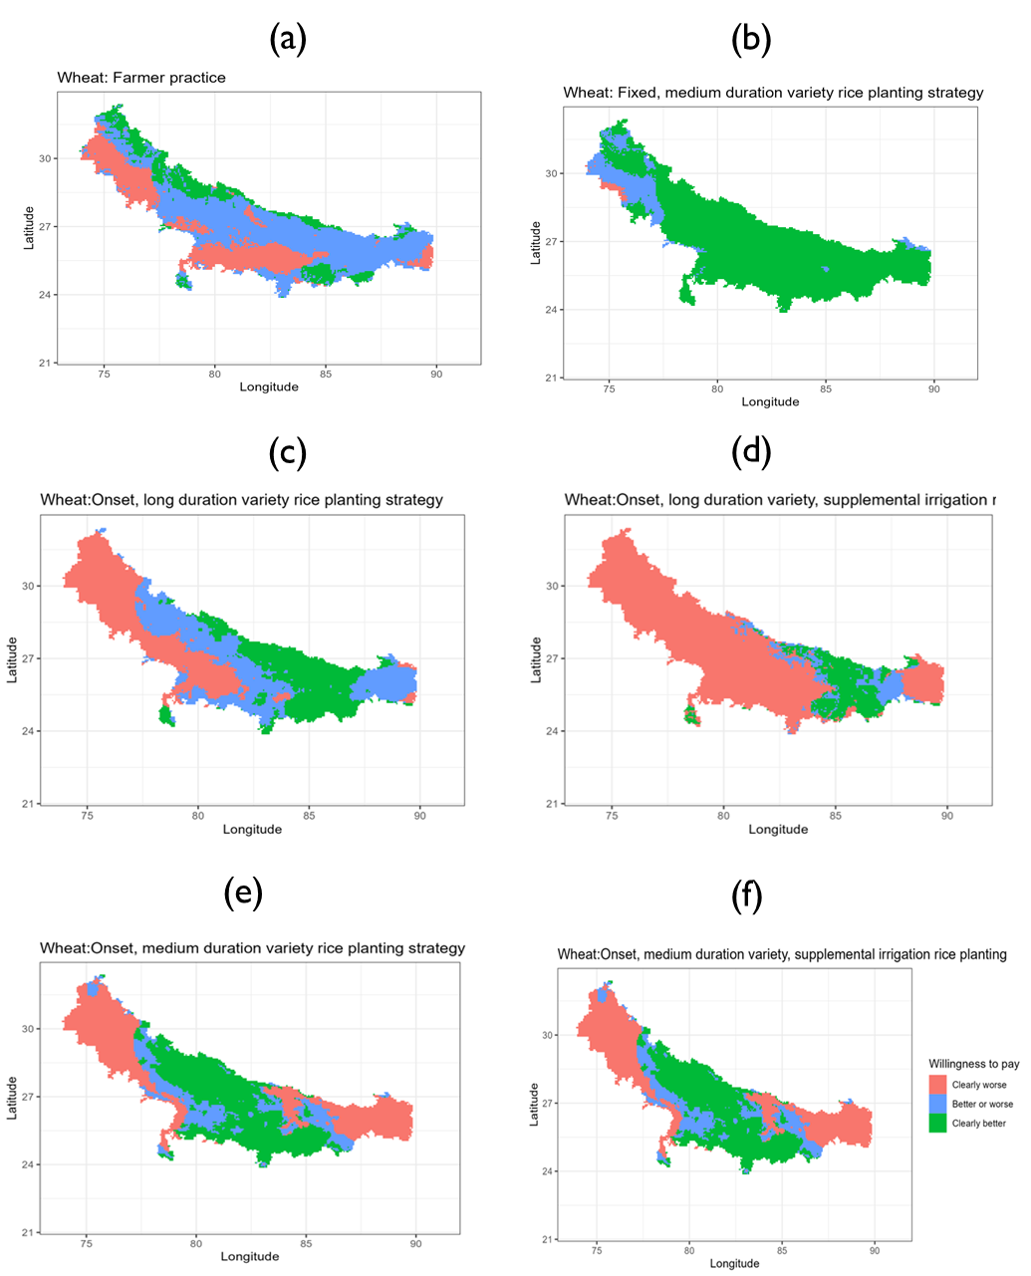

Figure 3: Willingness to pay (wheat yield t/ha) for the strategy against a fixed long duration variety reference strategy using second order stochastic dominance.

## 3.2. System-wide economic benefits for a risk averse farmer

### 3.2.1. System revenues

The approach involves using pixel level prices of rice and wheat to compute the revenues of following each of the scenarios. The pixel level prices are obtained by interpolating prices from the Landscape Diagnostic Survey (LDS) for 2017/18 season. We then use these economic indicators in the stochastic comparisons. Table 5 shows the descriptive statistics for the willingness to pay bounds. Starting with the percentage of pixels that would benefit from each of the scenarios as compared to the baseline, the statistics rows show that strategies are worse for farmers across most of the pixels are farmer practice (column 3) with 78% losing and onset medium with constrained irrigation (column 8) with 49% losing.

Table 5: Gross revenue WTP (thousand ruppes/ha) bounds with fixed long as baseline

|  |  |  |  |  |  |  |  |
| --- | --- | --- | --- | --- | --- | --- | --- |
| Bound | Statistics | S0-S1 | S2-S1 | S3-S1 | S4-S1 | S5-S1 | S6-S1 |
| Upper bound | Mean | -23.99 | 34.99 | 8.37 | -14.67 | 14.30 | 1.49 |
| Std.Dev | 25.96 | 28.30 | 41.11 | 47.53 | 29.59 | 31.35 |
| Min | -144.09 | -28.54 | -84.72 | -125.24 | -64.90 | -89.49 |
| 10th percentile | -56.03 | -15.52 | -45.24 | -74.99 | -26.87 | -37.83 |
| 25th percentile | -39.27 | 22.03 | -19.37 | -51.28 | -4.45 | -19.90 |
| Median | -24.18 | 41.04 | 1.34 | -18.60 | 15.28 | -1.92 |
| 75th percentile | -12.33 | 56.10 | 39.14 | 20.11 | 36.06 | 25.19 |
| 90th percentile | 1.85 | 66.82 | 69.81 | 56.16 | 53.93 | 45.26 |
| Max | 87.55 | 91.16 | 96.57 | 86.07 | 132.20 | 108.48 |
| Lower bound | Mean | -73.43 | -1.39 | -18.36 | -43.68 | -16.67 | -28.19 |
| Std.Dev | 36.34 | 25.91 | 43.02 | 49.08 | 28.35 | 30.59 |
| Min | -177.76 | -59.94 | -123.07 | -139.93 | -119.55 | -151.45 |
| 10th percentile | -113.83 | -28.09 | -77.92 | -109.68 | -46.58 | -65.46 |
| 25th percentile | -94.35 | -20.99 | -53.41 | -86.66 | -30.70 | -43.60 |
| Median | -72.95 | -6.29 | -13.44 | -42.45 | -19.58 | -29.30 |
| 75th percentile | -56.20 | 16.31 | 10.49 | -3.30 | -1.85 | -11.96 |
| 90th percentile | -29.14 | 36.79 | 37.99 | 22.05 | 20.96 | 11.44 |
| Max | 83.40 | 69.35 | 87.03 | 76.56 | 113.90 | 83.34 |
| WTP summary | Clearly better (share) | 0.02 | 0.42 | 0.36 | 0.23 | 0.23 | 0.16 |
| Not clear (share) | 0.09 | 0.42 | 0.16 | 0.14 | 0.44 | 0.32 |
| Clearly worse (share) | 0.89 | 0.16 | 0.48 | 0.63 | 0.32 | 0.52 |
| Number of cells | 17456.00 | 17456.00 | 17456.00 | 17456.00 | 17456.00 | 17456.00 |

Spatially, there are pockets for which a risk averse farmer would not switch to the recommended fixed date with long duration variety strategy especially in the central pixels of Bihar.

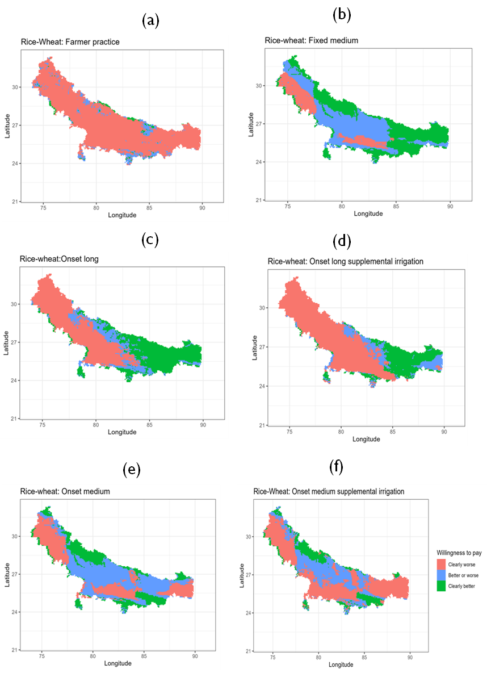

Figure 4: Spatial distribution of revenue WTP (where to target the scenarios)

### 3.2.2. System partial profits

Table 6 shows descriptive statistics for willingness to pay for partial profits (revenue-irrigation costs) for each of the planting date strategies as compared to fixed date-long duration rice variety strategy. As with productivity and revenue comparisons, farmer practice is a worse strategy for about 85% of the pixels in IGP. None of the strategies dominate across the entire IGP.

Table 6: Partial profits WTP (thousand rupees/ha) descriptive statistics

|  |  |  |  |  |  |  |  |
| --- | --- | --- | --- | --- | --- | --- | --- |
| Bound | Statistics | S0-S1 | S2-S1 | S3-S1 | S4-S1 | S5-S1 | S6-S1 |
| Upper bound | Mean | -15.31 | 40.40 | 12.30 | 7.84 | 23.80 | 25.40 |
| Std.Dev | 22.82 | 28.98 | 42.88 | 46.27 | 31.34 | 34.62 |
| Min | -97.77 | -25.01 | -80.65 | -95.69 | -62.89 | -82.90 |
| 10th percentile | -36.40 | -10.73 | -42.52 | -49.44 | -21.58 | -17.54 |
| 25th percentile | -26.88 | 24.88 | -16.26 | -27.25 | 7.19 | -1.91 |
| Median | -18.74 | 47.15 | 2.00 | 1.43 | 24.04 | 23.22 |
| 75th percentile | -8.09 | 62.14 | 48.44 | 41.74 | 48.21 | 52.55 |
| 90th percentile | 6.10 | 72.21 | 77.33 | 79.22 | 63.93 | 74.15 |
| Max | 99.85 | 96.57 | 103.13 | 112.42 | 137.49 | 129.42 |
| Lower bound | Mean | -50.40 | 3.51 | -16.12 | -24.19 | -8.78 | -5.70 |
| Std.Dev | 26.63 | 25.83 | 44.08 | 47.57 | 28.33 | 32.81 |
| Min | -126.29 | -54.20 | -115.70 | -112.73 | -103.66 | -118.82 |
| 10th percentile | -79.57 | -23.43 | -73.37 | -82.82 | -38.10 | -47.72 |
| 25th percentile | -66.27 | -16.27 | -54.83 | -66.11 | -23.19 | -23.23 |
| Median | -52.75 | -0.94 | -13.87 | -28.33 | -12.87 | -6.43 |
| 75th percentile | -35.94 | 20.98 | 16.24 | 13.97 | 6.85 | 12.31 |
| 90th percentile | -21.19 | 41.44 | 44.49 | 43.67 | 29.05 | 36.92 |
| Max | 89.66 | 76.40 | 90.44 | 97.08 | 120.33 | 99.99 |
| WTP summary | Clearly better (share) | 0.02 | 0.49 | 0.37 | 0.31 | 0.32 | 0.38 |
| Not clear (share) | 0.13 | 0.37 | 0.18 | 0.21 | 0.48 | 0.35 |
| Clearly worse (share) | 0.85 | 0.14 | 0.45 | 0.48 | 0.21 | 0.27 |
| Number of cells | 17420.00 | 17420.00 | 17420.00 | 17420.00 | 17420.00 | 17420.00 |

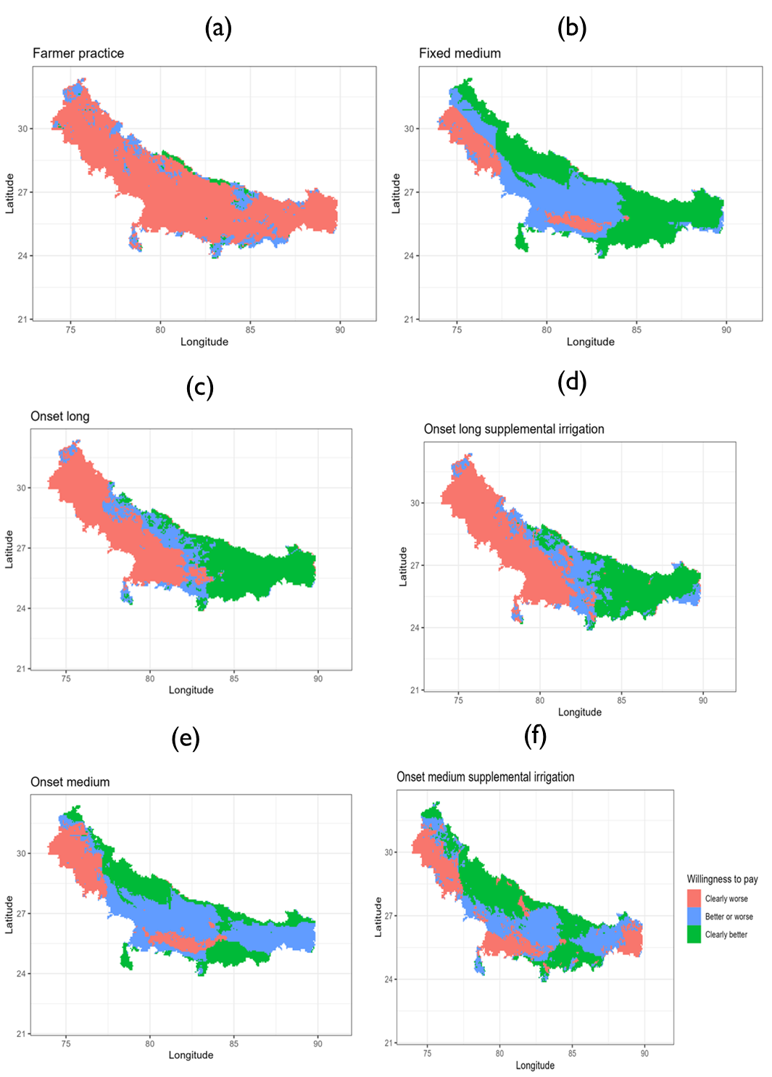

Figure 5: Spatial distribution of partial profit WTP (where to target the scenarios)

# 4. Recommended pixel level rice planting date strategy

The foregoing analyses has made binary comparisons. But the interest is on which scenario should be advocated for a particular location. To get this optimal scenario, we calculate the maximum upper bound WTP among the scenarios and the maximum lower WTP. If there is match on which scenario is selected and are all positive, then we recommend that scenario. Figure 6 shows the optimal rice planting date strategy. This is main graph for the paper recommending a robust strategy for each pixel from the optimization model of partial profits.

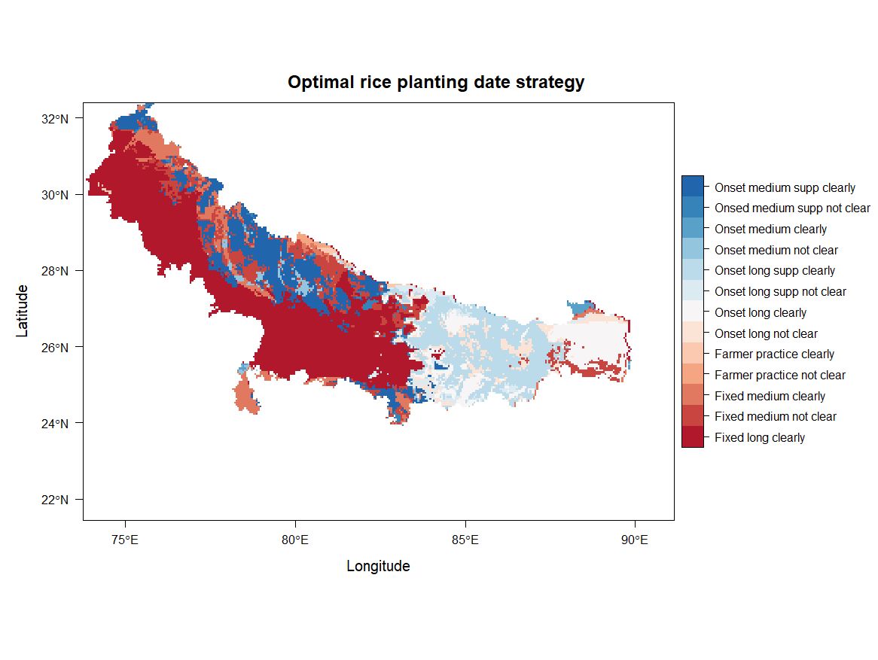

Figure 6: Optimal rice planting date strategy

Note: The strategies with suffix "clearly" have the maximum gains across all scenarios for both upper and lower bounds meaning that for all risk tolerances (risk aversion), this is the optimal strategy. The ones with the suffix "not clear" have the maximum upper bound but maximum lower bound is another strategy meaning only a risk neutral farmer will find this optimal. For risk averse farmers, it depends on their risk aversion (which we don't measure in this paper) to assign them a strategy in these locations.

# 5. Conclusion

Early sowing of rice has been proposed as the best strategy at optimizing productivity of rice-wheat rotation system in Bihar and the rest of the Indo-Gangetic Plains of India, Bangladesh, Nepal and Pakistan. Any cropping calendar adjustment is expected to be risky to the farmers and may be economically suboptimal. In this paper, we use an approach proposed by Hurley et al (2018) of using computational second order stochastic dominance to calculate lower and upper bounds for which any risk averse farmer will be willing to pay to adopt an alternative rice planting date strategy.

We find a substantial spatial variation in the optimal planting date strategies. Planting rice on a fixed date with a long duration variety is recommended for the western part of the IGP while planting rice at monsoon onset with a long duration variety is recommended for eastern part of the IGP.

# References

Hurley, T., Koo, J., and Tesfaye, K. 2018. “Weather risk: how does it change the yield benefits of nitrogen fertilizer and improved maize varieties in sub-Saharan Africa?” *Agricultural Economics* 49: 711-723. Doi: 10.1111/agec.12454.

Ishtiaque, A., Singh, S., Lobell, D., Singh, B., Fishman, R., and Jain, M. 2022. “Prior crop season management constrains farmer adaptation to warming temperatures: Evidence from the Indo-Gangetic Plains.” *Science of the Total Environment* 807 (2). Doi: <https://doi.org/10.1016/j.scitotenv.2021.151671>.

Levy, H. 2016. “Stochastic Dominance: Investment Decision Making under Uncertainty.” Third Edition. Springer.

Meyer, J.1977. “Second degree stochastic dominance with respect to a function.” *International Economic Review* 18(2): 477-487. Doi: <https://doi.org/10.2307/2525760>.

Montes, C., Urfels, A., Han, E., and Balwinder-Singh. 2022. “Planting rice at monsoon onset could mitigate the impact of temperature stress on rice-wheat systems of Bihar, India.” *Atmosphere* 14(1), 40. Doi:  <https://doi.org/10.3390/atmos14010040>.

McDonald, A.J., Balwinder-Singh., Keil, A., Srivastava, A., Craufurd, P., Kishore, A., Kumar, V., Paudel, G., Singh, S., Singh, A.K., Sohane, R.K., and Malik, R.K. 2022. “Time management governs climate resilience and productivity in the coupled rice-wheat cropping systems of eastern India.” Nature Food. Doi: <https://doi.org/10.1038/s43016-022-00549-0>.

Markowitz, H.M. 1959. “Portfolio selection: Efficient diversification of investments”. Cowles Foundation for Research in Economics. Yale University. Url: <https://cowles.yale.edu/sites/default/files/2022-09/m16-all.pdf>.

Nalley, L.L., and Barkley, A.P. 2010. “Using Portfolio Theory to Enhance Wheat Yield Stability in Low-Income Nations: An Application in the Yaqui Valley of Northwestern Mexico.” *Journal of Agricultural and Resource Economics* 35(2): 334-347. Url: <https://www.jstor.org/stable/41960521>.

Newport, D., Lobell, D.B., Singh, B., Srivastiva, A., Rao, P., Umashaanker, M., Malik, R.K., McDonald, A., and Jain, M. 2020. “Factors Constraining Timely Sowing of Wheat as an Adaptation to Climate Change in Eastern India.” *Weather, Climate and Society* 515-528. Doi: <https://doi.org/10.1175/WCAS-D-19-0122.1>.

Suri, T. 2011. “Selection and Comparative Advantage in Technology Adoption.” *Econometrica* 79(1): 159-209. Doi:10.3982/ECTA7749.

Urfels, A., McDonald, A.J., Halsema, G., Struik, P.C., Kumar, P., Malik, R.K., Poonia, S.P., Singh, B., Singh, D.K., Singh, M., Krupnik, T.J. 2021. “Socio-ecological analysis of timely rice planting in Eastern India.” *Agronomy for Sustainable Development* 41: 14. Doi: <https://doi.org/10.1007/s13593-021-00668-1>.

Urfels, A., Montes, C., Balwinder-Singh, Halsema, G., Struik, P., Krupnik, T., and McDonald, J. 2022. “Climate adaptative rice planting strategies diverge across environmental gradients in the Indo-Gangetic Plains.” *Environmental Research Letters* 17: 124030. Doi: 10.1088/1748-9326/aca5a2.

# Appendices

## Appendix A: Fixed long as baseline with zero yield entries, Bihar

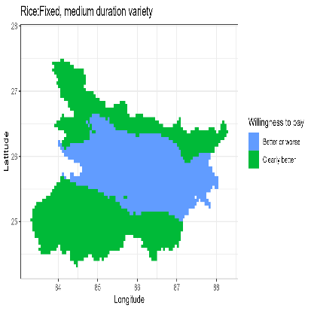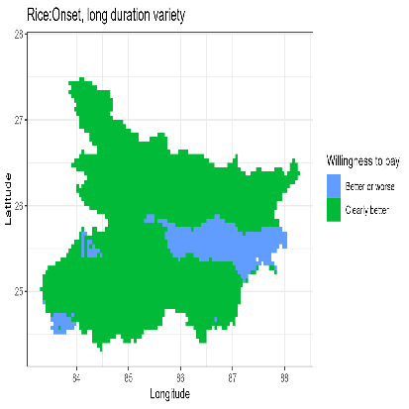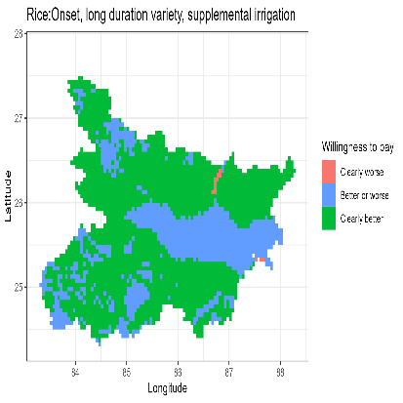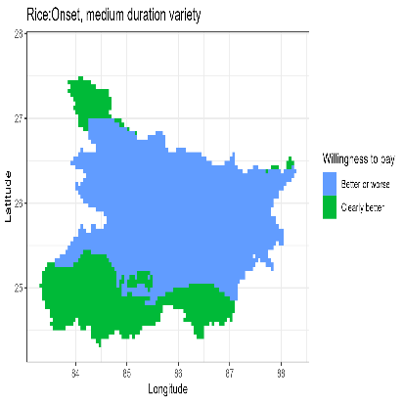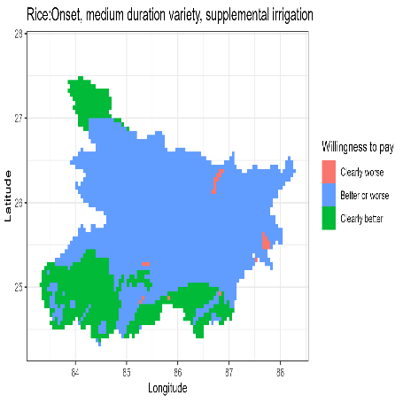

a

b

c

d

e

f

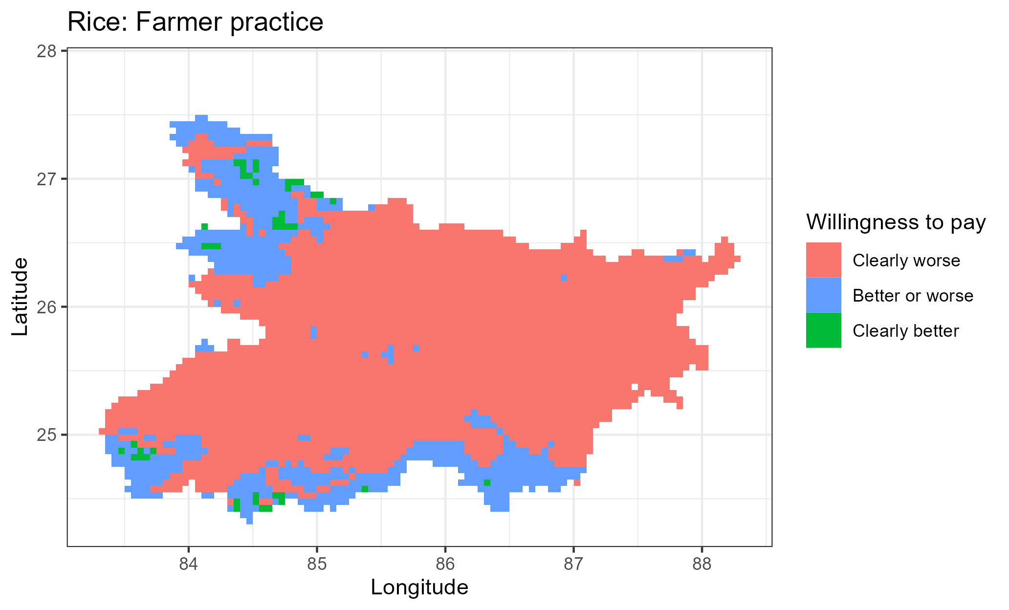

Figure A1: Rice WTP decisions as compared to fixed long strategy

a

b

c

d

e

f

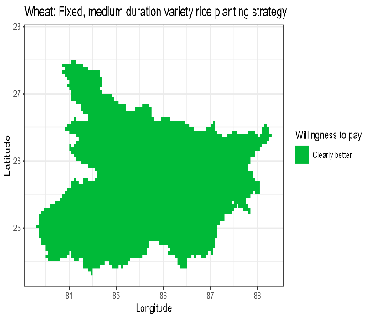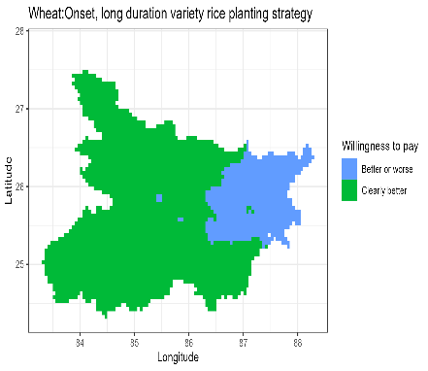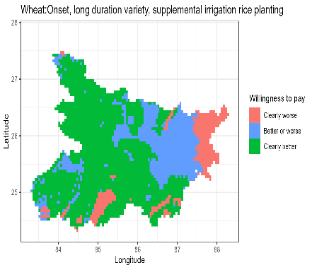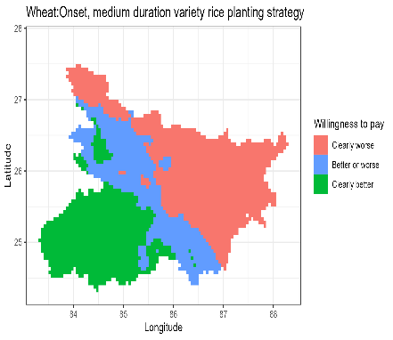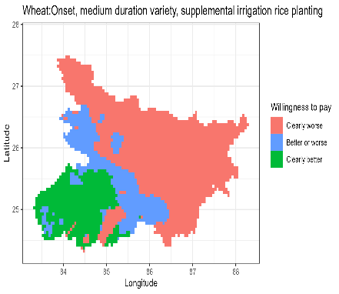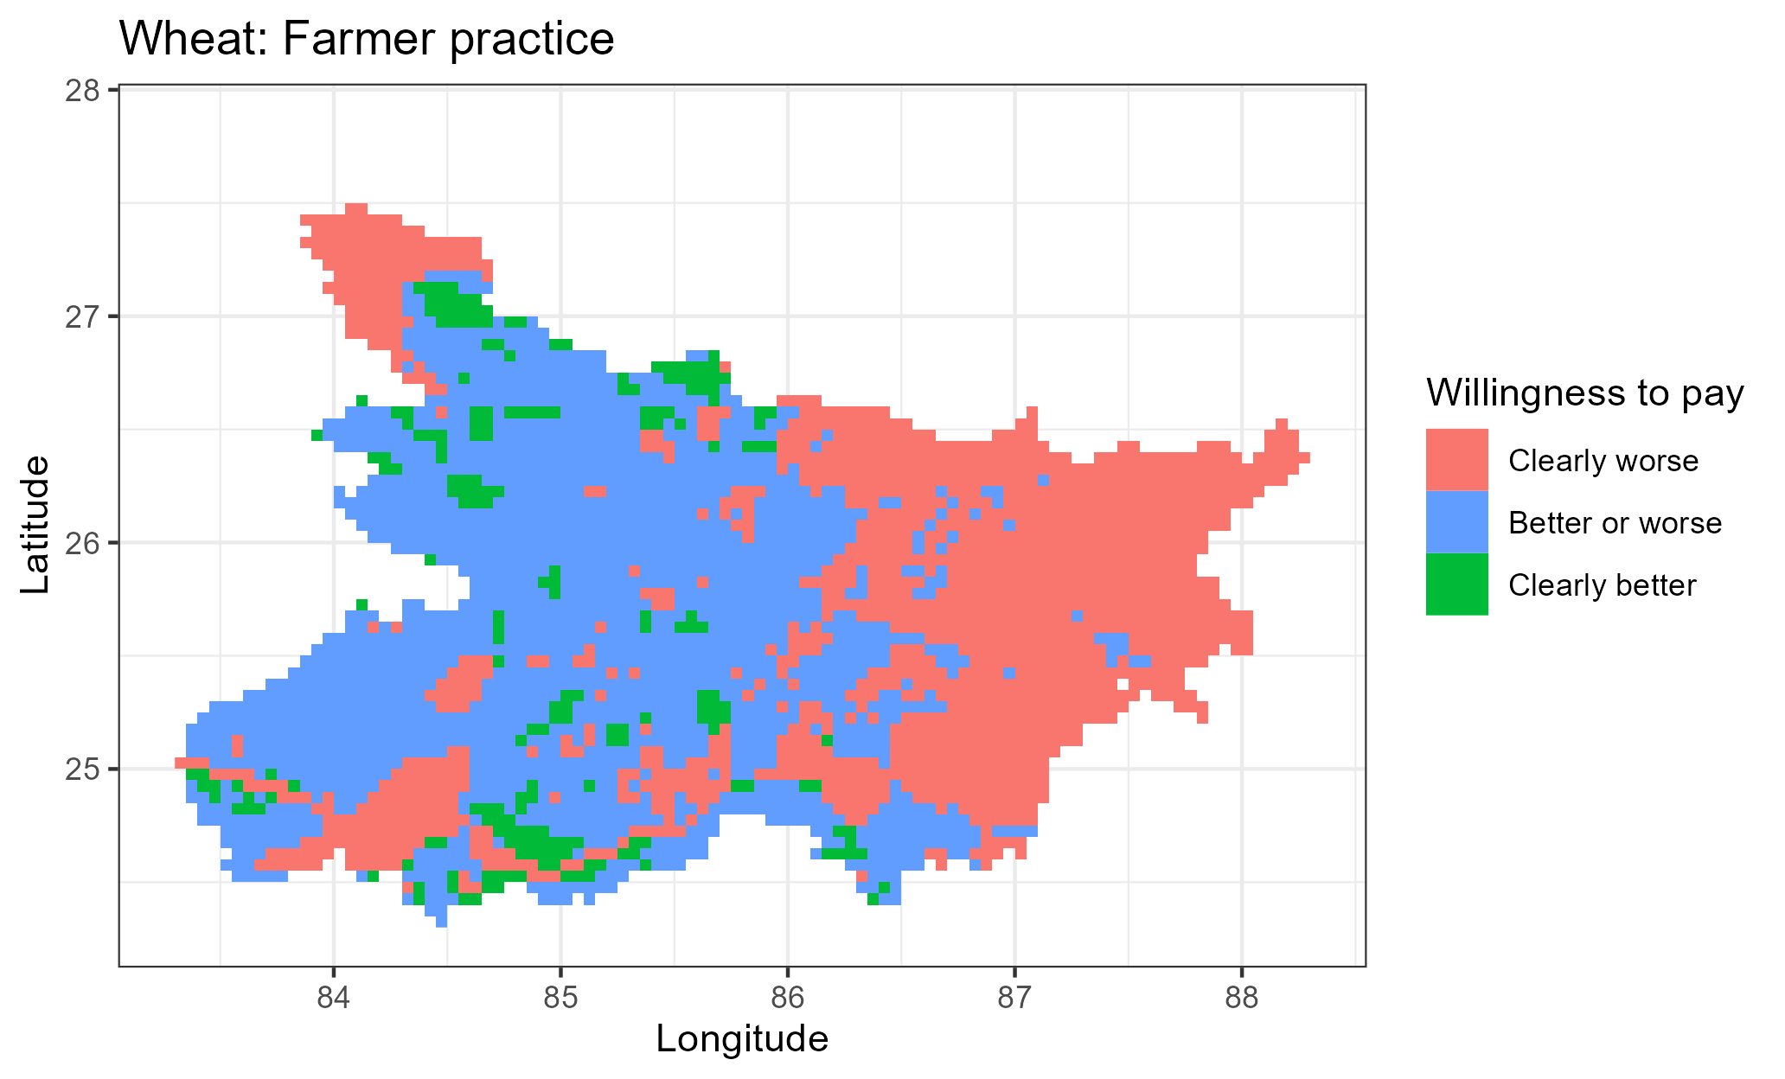

Figure A2: Wheat WTP decisions as compared to fixed long strategy

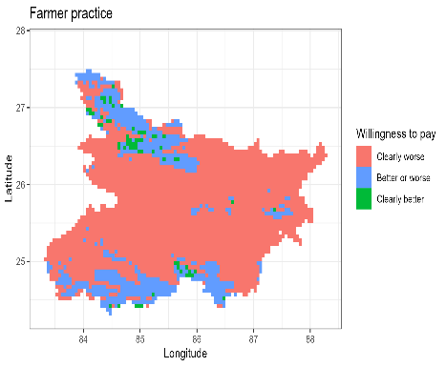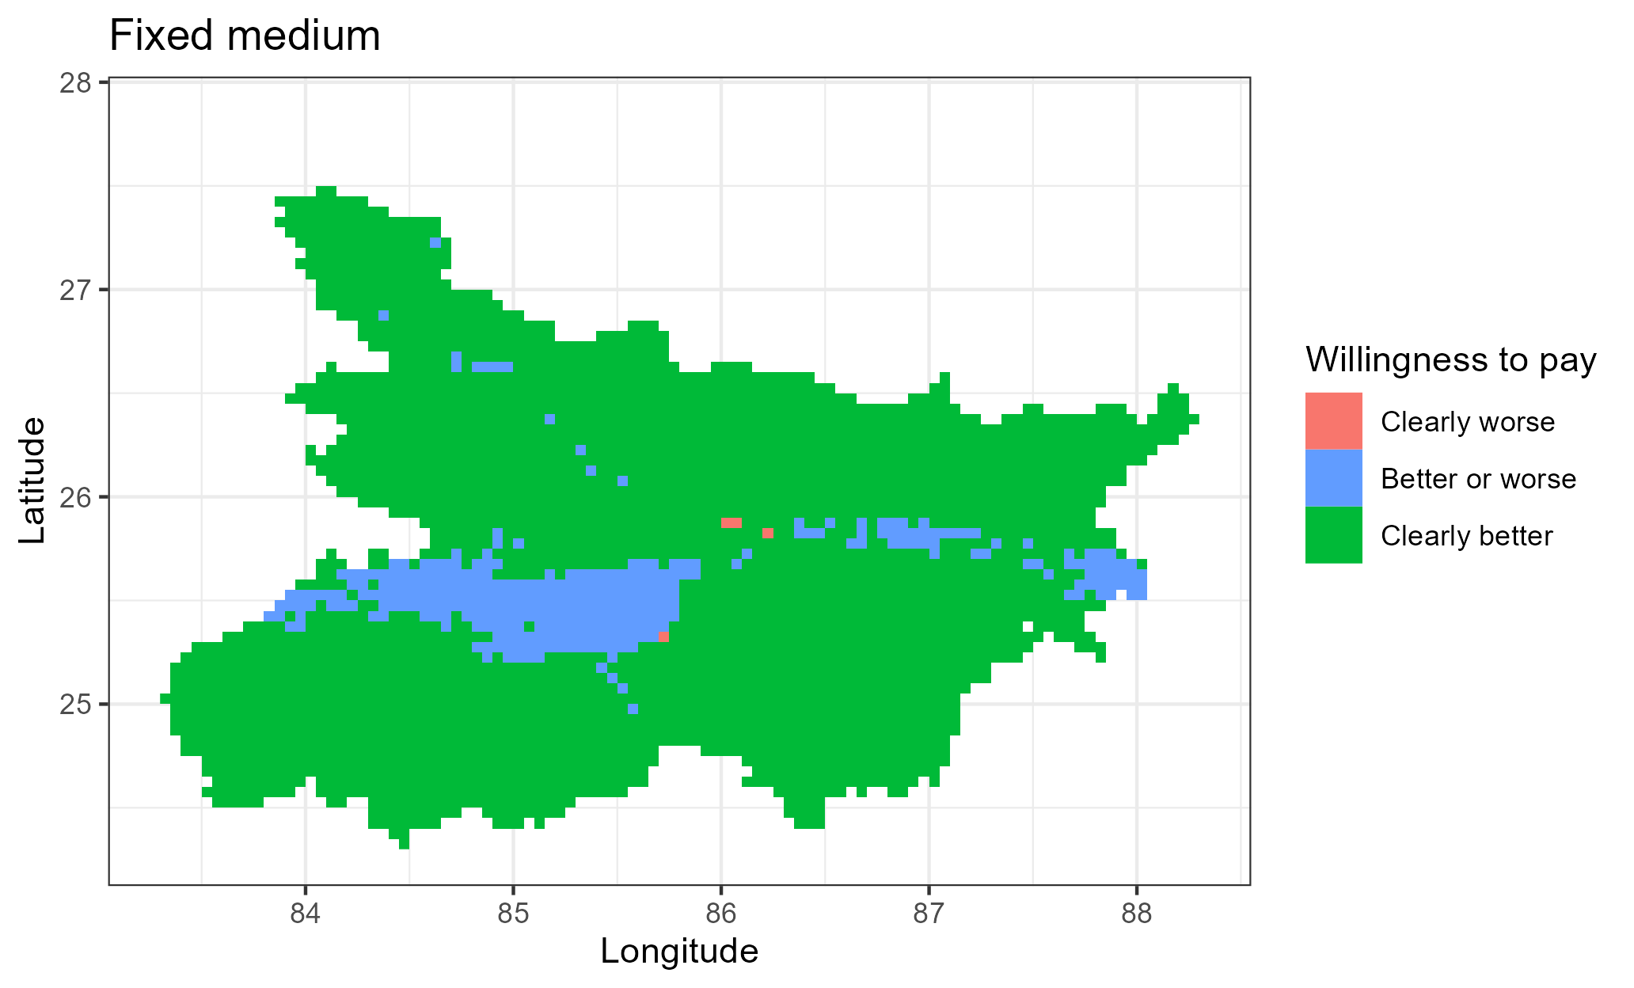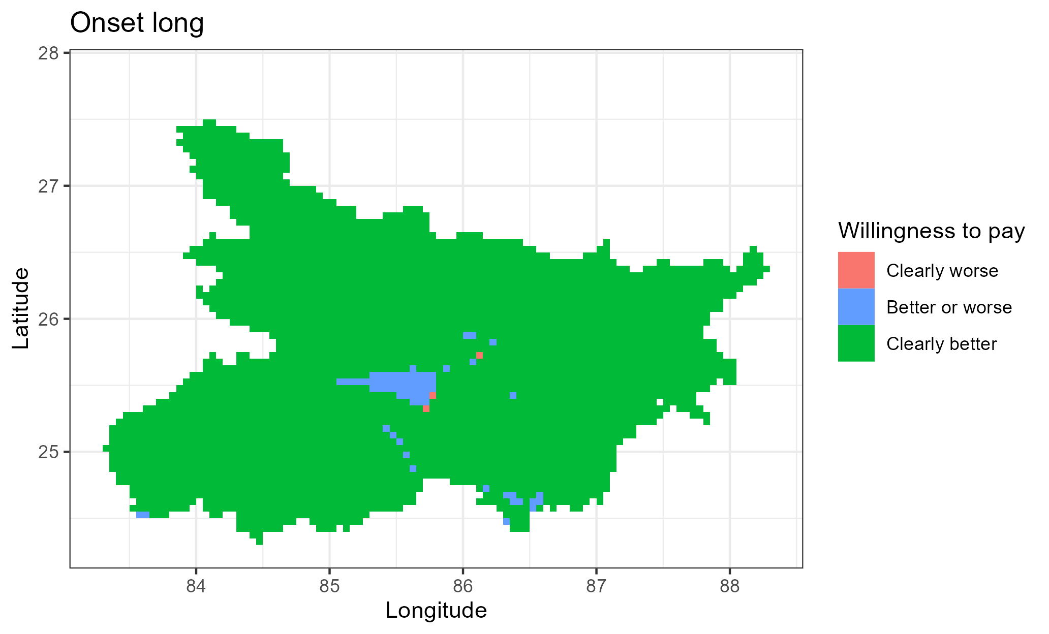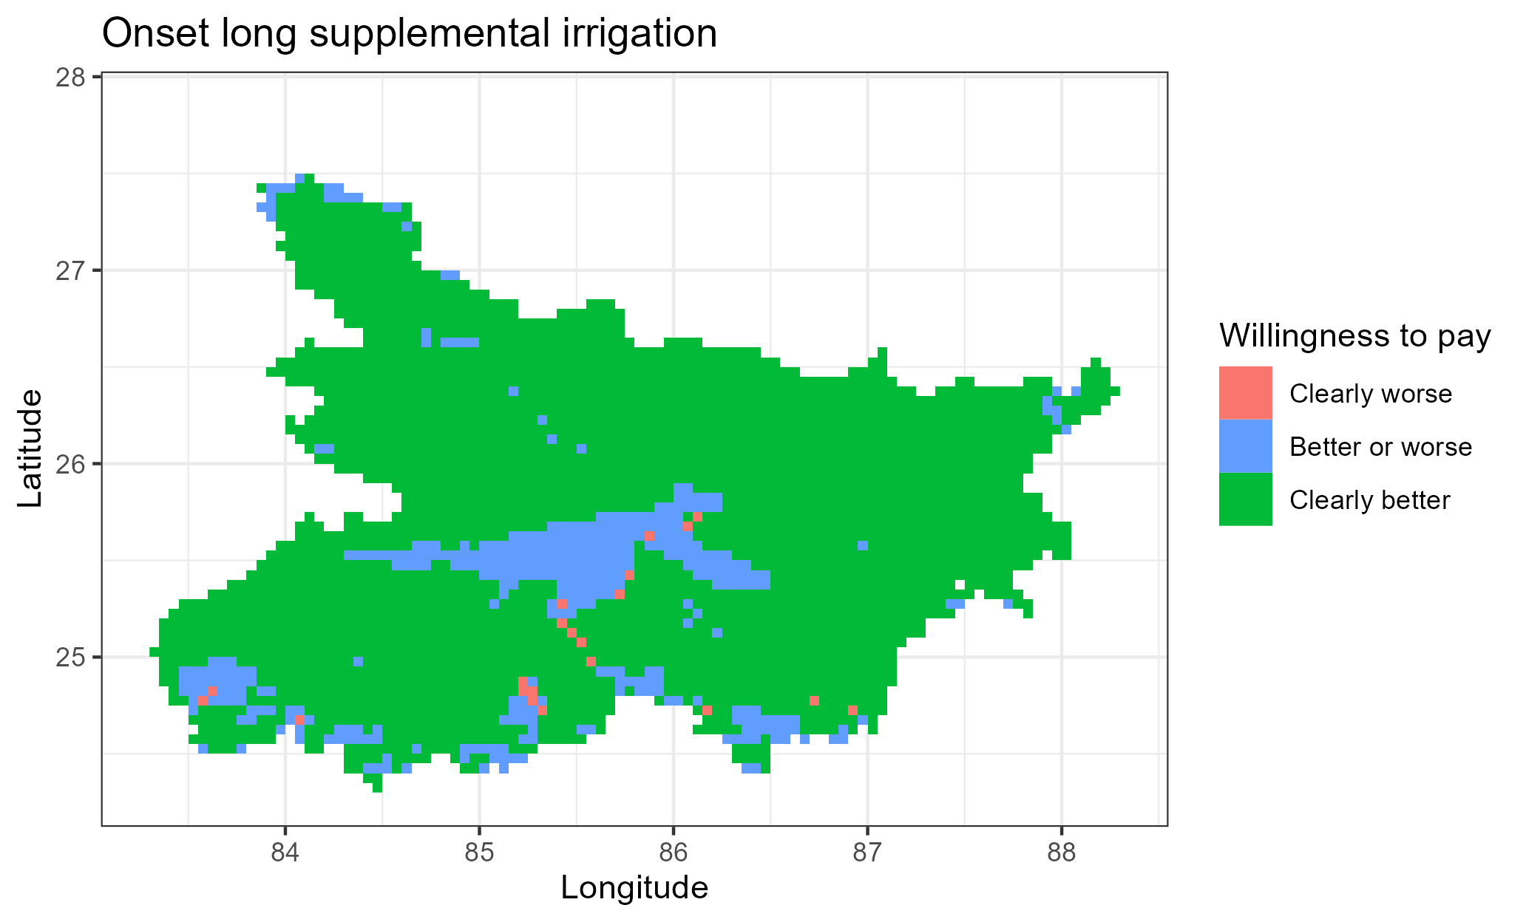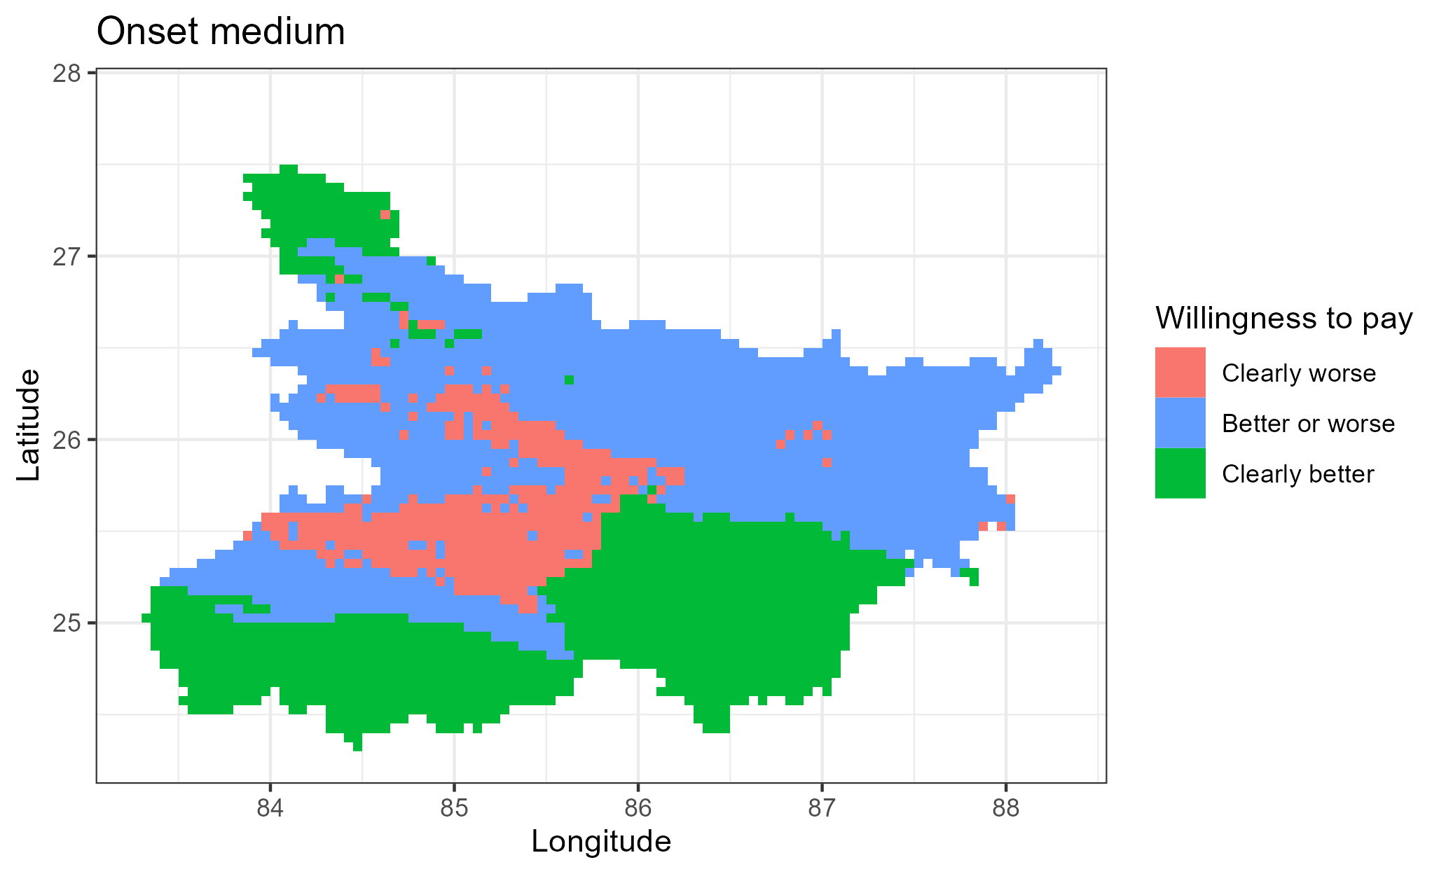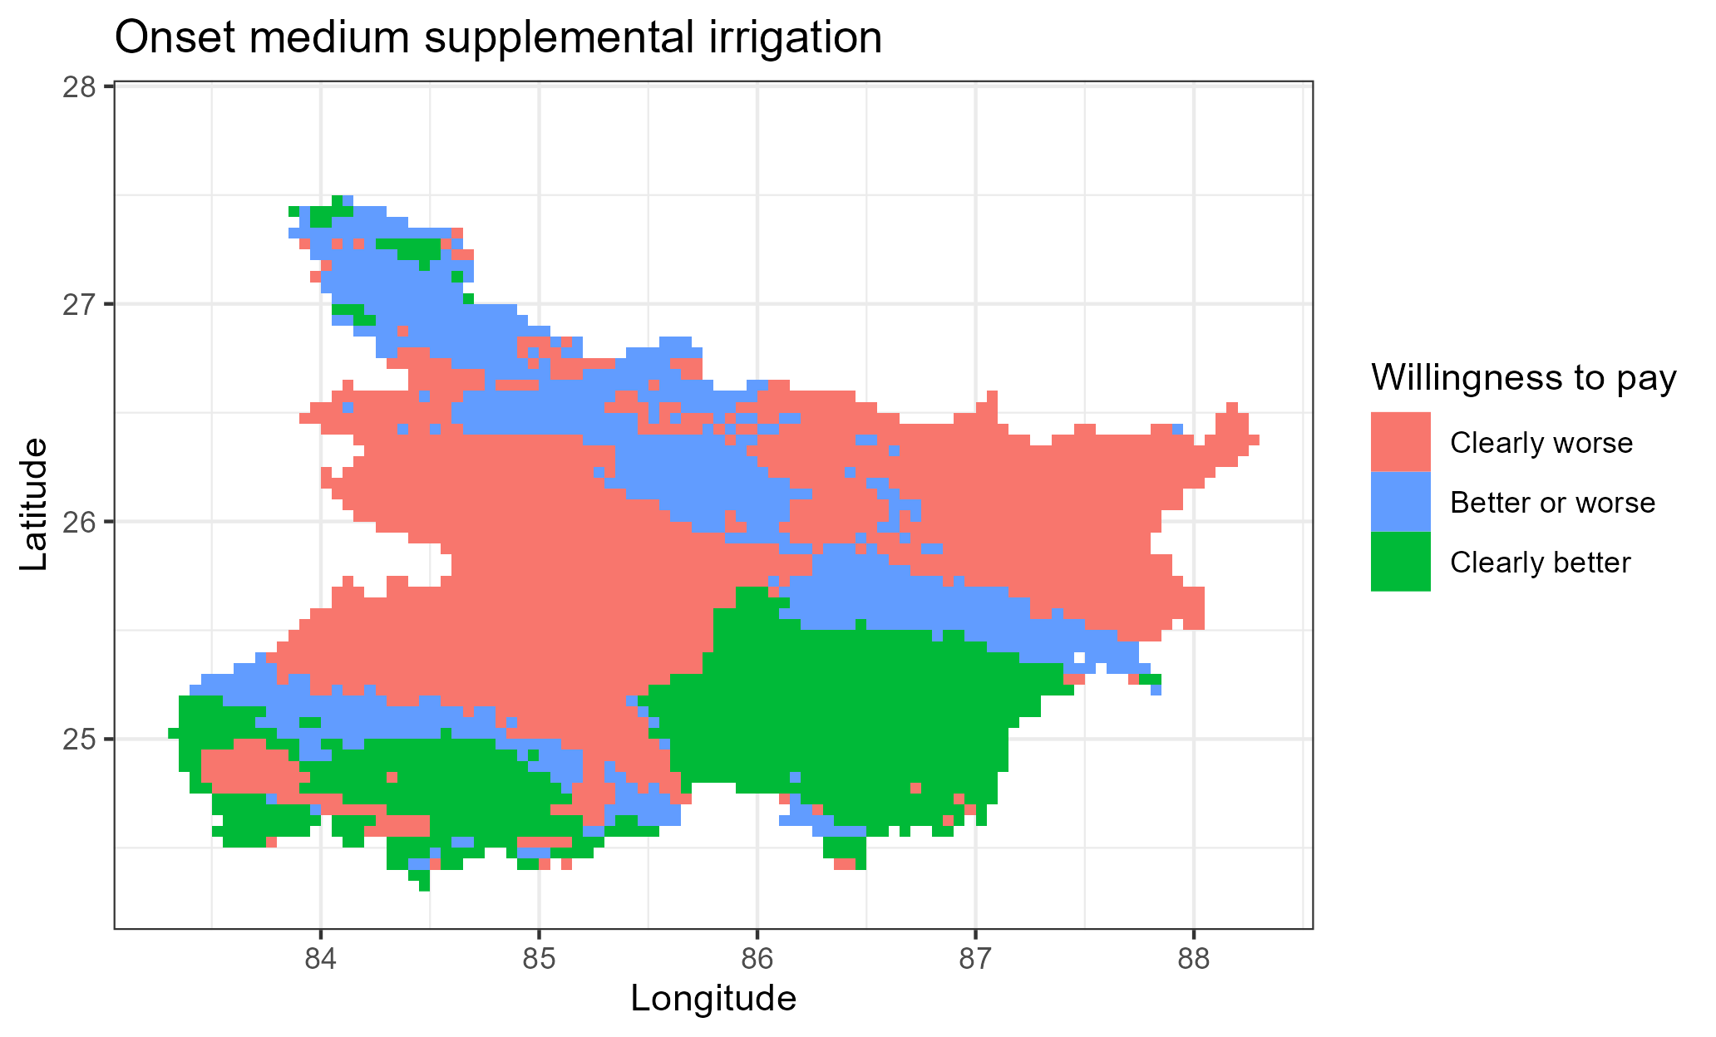

Figure A3: Revenue WTP decisions as compared to fixed long strategy

Table A1: Rice WTP bounds with fixed long as baseline [with zero yield entries], Bihar

|  |  |  |  |  |  |  |  |
| --- | --- | --- | --- | --- | --- | --- | --- |
| Bound | Statistics | S0-S1 | S2-S1 | S3-S1 | S4-S1 | S5-S1 | S6-S1 |
| Upper bound | Mean | -0.84 | 2.92 | 3.95 | 3.57 | 1.91 | 1.80 |
| Standard deviation | 1.57 | 0.41 | 0.62 | 0.63 | 0.35 | 0.45 |
| Min | -2.20 | 2.27 | 2.89 | -1.75 | 1.29 | -1.95 |
| 10th percentile | -1.92 | 2.50 | 3.18 | 3.03 | 1.55 | 1.45 |
| 25th percentile | -1.87 | 2.61 | 3.44 | 3.20 | 1.64 | 1.60 |
| Median | -1.69 | 2.79 | 3.85 | 3.48 | 1.84 | 1.79 |
| 75th percentile | -0.41 | 3.18 | 4.40 | 3.95 | 2.13 | 2.03 |
| 90th percentile | 1.86 | 3.49 | 4.85 | 4.37 | 2.40 | 2.31 |
| Max | 4.88 | 4.19 | 5.73 | 5.33 | 3.12 | 2.97 |
| Lower bound | Mean | -3.21 | 0.44 | 1.43 | 0.73 | -0.61 | -0.86 |
| Standard deviation | 1.44 | 1.38 | 1.23 | 1.18 | 1.33 | 1.28 |
| Min | -6.59 | -1.73 | -1.71 | -3.91 | -2.66 | -3.04 |
| 10th percentile | -5.31 | -1.31 | -0.10 | -0.44 | -2.24 | -2.29 |
| 25th percentile | -4.28 | -0.66 | 0.43 | -0.12 | -1.68 | -1.91 |
| Median | -3.08 | 0.25 | 1.29 | 0.57 | -0.84 | -1.14 |
| 75th percentile | -2.06 | 1.37 | 2.27 | 1.47 | 0.28 | -0.08 |
| 90th percentile | -1.82 | 2.68 | 3.25 | 2.39 | 1.49 | 1.20 |
| Max | 0.76 | 3.69 | 4.79 | 4.37 | 2.45 | 2.35 |
| WTP summary | Clearly better (share) | 0.01 | 0.57 | 0.87 | 0.69 | 0.29 | 0.24 |
| Not clear (share) | 0.19 | 0.43 | 0.13 | 0.30 | 0.71 | 0.75 |
| Clearly worse (share) | 0.79 | 0.00 | 0.00 | 0.00 | 0.00 | 0.01 |
| Number of cells | 3386.00 | 3386.00 | 3386.00 | 3386.00 | 3386.00 | 3386.00 |

Table A2: Wheat WTP bounds with fixed long as baseline, Bihar

|  |  |  |  |  |  |  |  |
| --- | --- | --- | --- | --- | --- | --- | --- |
| Bound | Statistics | S0-S1 | S2-S1 | S3-S1 | S4-S1 | S5-S1 | S6-S1 |
| Upper bound | Mean | -0.34 | 1.28 | 1.23 | 0.64 | 0.20 | -0.37 |
| Standard deviation | 0.98 | 0.12 | 0.38 | 0.69 | 0.76 | 1.03 |
| Min | -2.60 | 0.60 | 0.18 | -2.39 | -1.11 | -2.39 |
| 10th percentile | -1.98 | 1.15 | 0.64 | -0.09 | -0.80 | -1.78 |
| 25th percentile | -1.16 | 1.23 | 0.98 | 0.48 | -0.37 | -1.22 |
| Median | 0.05 | 1.30 | 1.29 | 0.75 | 0.11 | -0.36 |
| 75th percentile | 0.32 | 1.37 | 1.50 | 1.04 | 0.82 | 0.47 |
| 90th percentile | 0.59 | 1.40 | 1.65 | 1.25 | 1.32 | 1.10 |
| Max | 1.59 | 1.53 | 2.05 | 1.91 | 1.69 | 1.61 |
| Lower bound | Mean | -1.71 | 1.03 | 0.66 | 0.04 | -0.24 | -1.15 |
| Standard deviation | 1.23 | 0.12 | 0.61 | 0.90 | 0.78 | 1.10 |
| Min | -3.72 | 0.38 | -0.89 | -3.47 | -1.42 | -3.72 |
| 10th percentile | -3.13 | 0.88 | -0.26 | -1.04 | -1.08 | -2.18 |
| 25th percentile | -2.64 | 0.98 | 0.23 | -0.34 | -0.87 | -1.88 |
| Median | -2.11 | 1.06 | 0.78 | 0.25 | -0.47 | -1.60 |
| 75th percentile | -0.01 | 1.11 | 1.17 | 0.64 | 0.36 | -0.49 |
| 90th percentile | 0.00 | 1.15 | 1.34 | 0.93 | 1.07 | 0.81 |
| Max | 1.34 | 1.24 | 1.62 | 1.49 | 1.35 | 1.23 |
| WTP summary | Clearly better (share) | 0.06 | 1.00 | 0.80 | 0.64 | 0.31 | 0.19 |
| Not clear | 0.52 | 0.00 | 0.20 | 0.25 | 0.25 | 0.19 |
| Clearly worse (share) | 0.42 | 0.00 | 0.00 | 0.11 | 0.44 | 0.62 |
| Number of cells | 3386.00 | 3386.00 | 3386.00 | 3386.00 | 3386.00 | 3386.00 |

Table A3: Revenue WTP descriptive, Bihar

|  |  |  |  |  |  |  |  |
| --- | --- | --- | --- | --- | --- | --- | --- |
| Bound | Statistics | S0-S1 | S2-S1 | S3-S1 | S4-S1 | S5-S1 | S6-S1 |
| 1 | 2 | 3 | 4 | 5 | 6 | 7 | 8 |
| Upper bound | Mean | -20013.05 | 55883.71 | 63616.27 | 49155.51 | 20429.77 | 7515.66 |
| Standard deviation | 32655.19 | 9074.47 | 17482.79 | 18110.54 | 18591.31 | 22571.44 |
| Min | -95787.35 | -10517.52 | -4369.18 | -19391.88 | -39021.17 | -50886.52 |
| 10th percentile | -59656.73 | 43928.94 | 38320.78 | 24205.65 | -867.53 | -16172.84 |
| 25th percentile | -51206.99 | 49765.59 | 49675.54 | 36655.93 | 4862.05 | -10466.29 |
| Median | -20973.23 | 56612.31 | 66844.77 | 52036.13 | 17028.43 | 228.33 |
| 75th percentile | -4138.39 | 62657.69 | 77845.09 | 63242.54 | 35833.15 | 26593.53 |
| 90th percentile | 24233.15 | 66609.76 | 85588.52 | 70133.90 | 49660.69 | 43570.32 |
| Max | 81513.61 | 77485.07 | 99480.34 | 88532.49 | 65034.09 | 61649.20 |
| Lower bound | Mean | -65401.51 | 22156.76 | 34908.06 | 19381.06 | -5512.13 | -15873.31 |
| Standard deviation | 30942.86 | 18377.46 | 19462.07 | 19031.29 | 24394.58 | 25250.42 |
| Min | -155222.24 | -30504.21 | -22649.54 | -49949.50 | -50621.89 | -67245.17 |
| 10th percentile | -106733.31 | 181.31 | 10065.78 | -2004.77 | -35187.29 | -46957.71 |
| 25th percentile | -89550.75 | 8369.37 | 20432.33 | 8001.31 | -24179.36 | -35355.27 |
| Median | -66430.47 | 19168.12 | 33537.89 | 18166.67 | -11178.09 | -19318.34 |
| 75th percentile | -44071.09 | 34650.94 | 48244.30 | 30751.22 | 13467.91 | 1582.32 |
| 90th percentile | -22426.40 | 50199.19 | 62462.09 | 45209.79 | 30279.24 | 19949.24 |
| Max | 77859.21 | 67605.46 | 84539.77 | 74983.11 | 55539.64 | 52194.78 |
| WTP summary | Clearly better (share) | 0.02 | 0.90 | 0.98 | 0.88 | 0.37 | 0.26 |
| Not clear (share) | 0.20 | 0.09 | 0.02 | 0.12 | 0.51 | 0.24 |
| Clearly worse (share) | 0.78 | 0.00 | 0.00 | 0.01 | 0.13 | 0.49 |
| Number of cells | 3429.00 | 3429.00 | 3429.00 | 3429.00 | 3429.00 | 3429.00 |

## Appendix C: Price sensitivity, Bihar

The analyses so far have focused on productivity gains to rice planting date adjustment. However, cost of production may also be affected by these adjustments. The changes in the cost of production may be due to direct changes in the inputs (e.g., alternative variety may be more expensive, sowing labor or hired machinery may be costly during the proposed sowing dates or irrigation may be costly). The changes may also be due to indirect changes in the production system. For example, sowing a long duration variety may require more irrigation which then increases irrigation costs. There are no studies that compute these costs comprehensively. We therefore test the robustness of the decisions on which strategy is beneficial to the farmers by using multiple of cost-output price ratios.

To test the robustness of the willingness to pay measures, we conduct a simple sensitivity analysis in which we vary the differential input price ratio of cost of the proposed rice planting strategy to the output prices. This is given by

$$kg of wheat (or rice) required to pay for planting date adjustment per ha(kg/ha)=\frac{Total cost of rice planting strategy adjustment per ha \left(\frac{Rs}{ha}\right) }{Price of wheat (or rice) per kg (\frac{Rs}{kg})}$$

Figure C1 shows the percentage distribution of risk averse farmers who would prefer that strategy as compared to the fixed long rice planting given increase input cost-output price ratio. At zero input cost changes, the percentage of farmers who prefer the corresponding strategies are as in table 2 and table 3. Panel (a) of Figure 4 shows that wheat is more responsive to changes in the costs of production as compared to rice. Overall, the ordering of the strategies remains intact with constant changes in costs of production except for implausibly high costs of production.

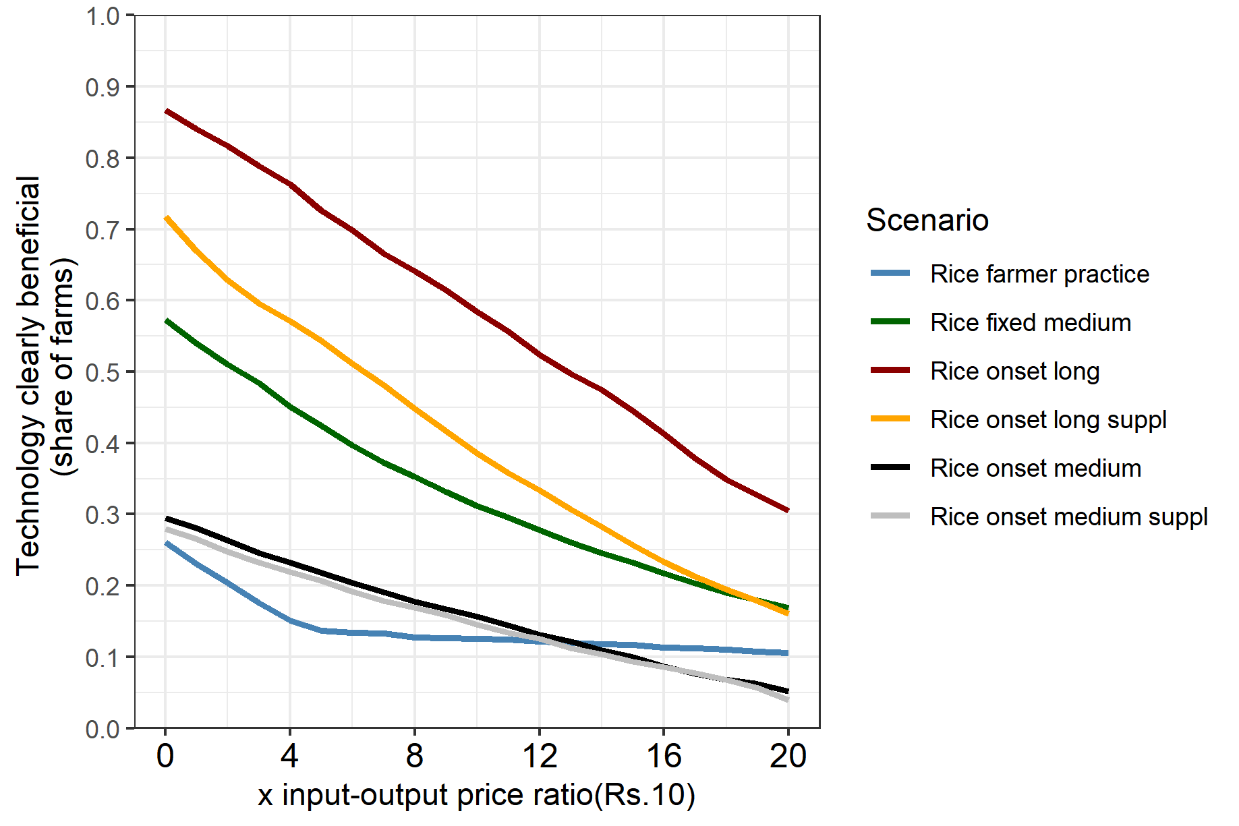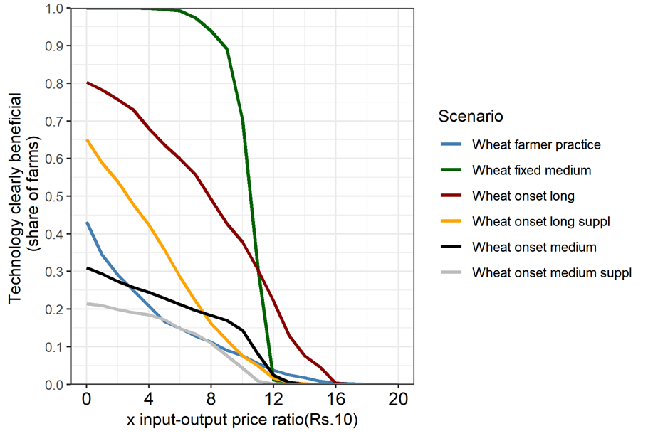

a. Without zero yield entries

Rice

Wheat

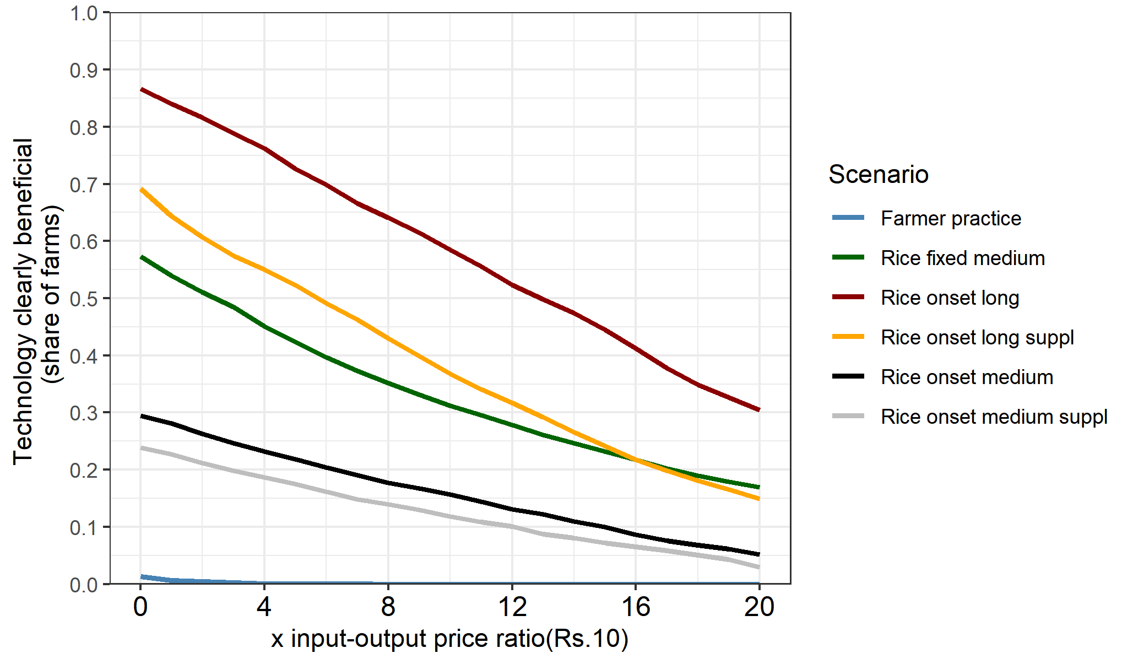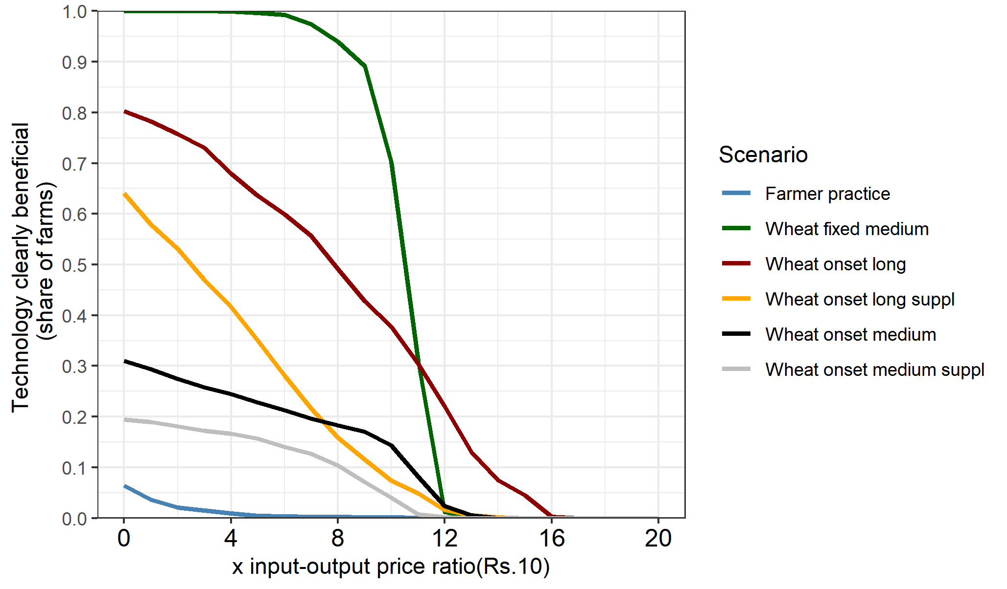

b. With zero yield entries

Rice

Wheat

Figure C1: Price sensitivity

1. The APSIM crop simulation model is available here: <https://git.wageningenur.nl/urfel001/igp-simulation-setup>.